**Pizza Sales Project - SQL**

* Install SQL server and workbench - [Install MySQl Workbench and server](https://www.youtube.com/watch?v=u96rVINbAUI)
* Data set (csv files) -> Need to import them in MySQL workbench.
* Create a database named Pizza hut and import the csv data files as tables.

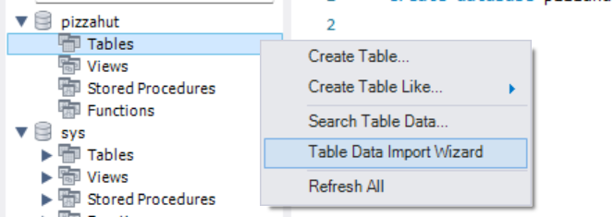

* For smaller files we could do the above, but in case we have larger files then it might become difficult. In that case you need to create the table by yourself - here we did for orders

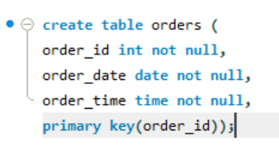

And then do table data import wizard.

* Since we have csv files we did this. If data was in db itself then good to go.
* Now start the analysis - TIP-> Ctrl+B to beautify a query.
* Start the analysis

1. **Total number of orders placed**

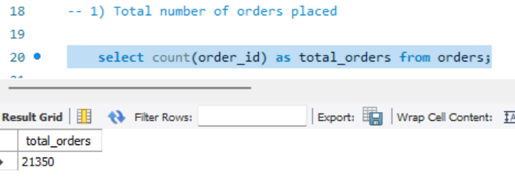

1. **Total Revenue generated from pizza sales**

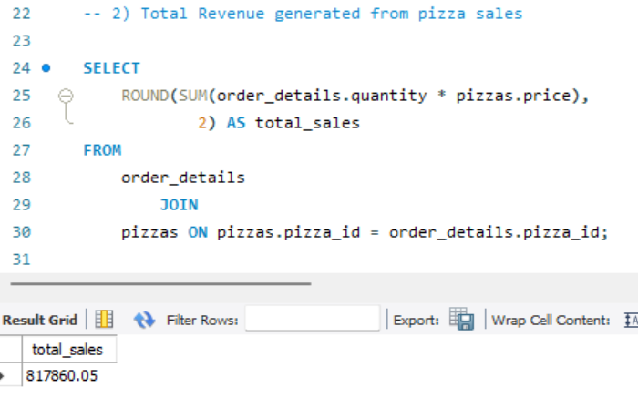

1. **Which is the highest priced pizza?**

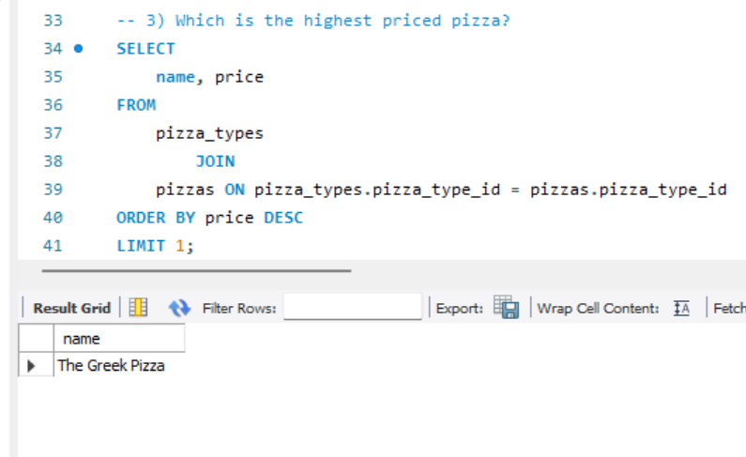

1. **Which is the most common pizza size ordered?**

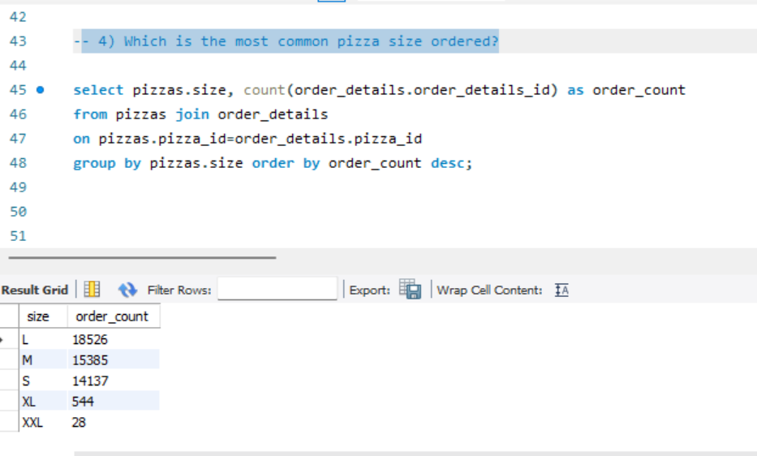

1. **Which are the 5 most ordered pizza types along with their quantities**

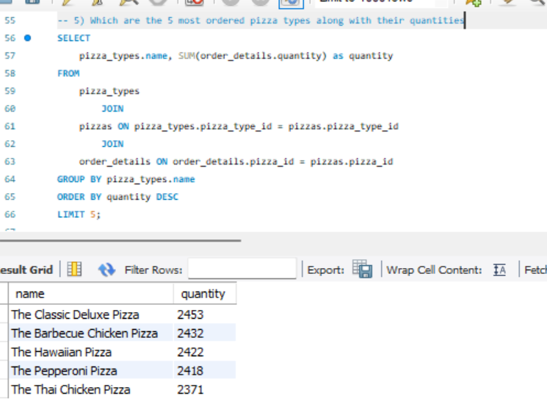

1. **Find the total quantity of each pizza ordered**

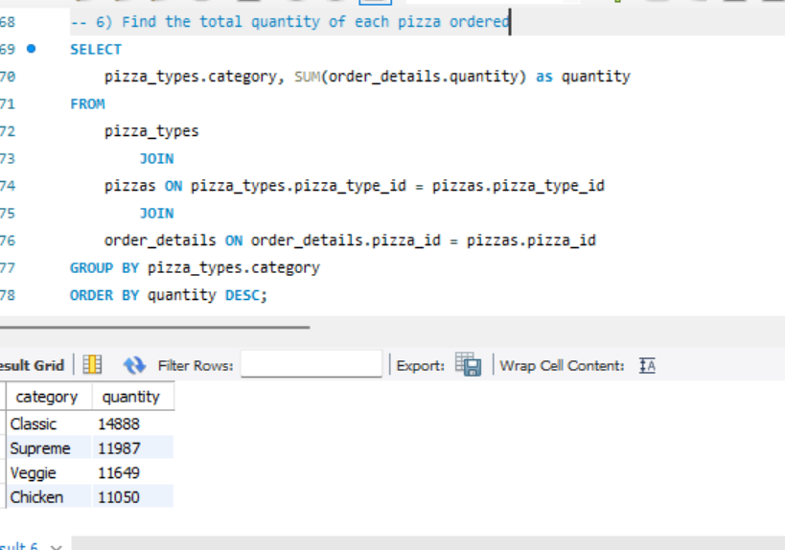

1. **Distribution of orders by hour of the day**

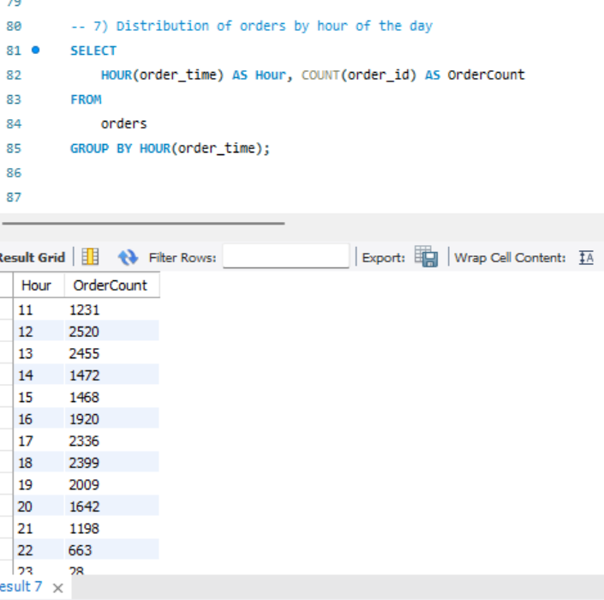

1. **Category wise distribution of pizzas**

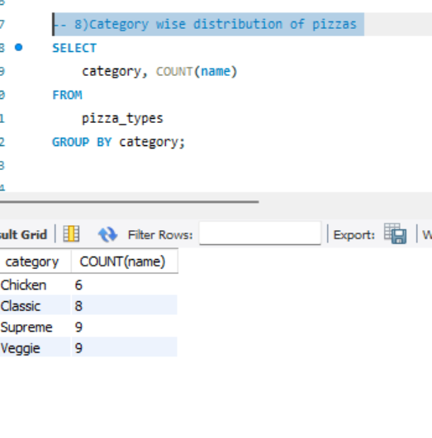

1. **Group the orders by date and calculate average number of pizzas ordered per day**

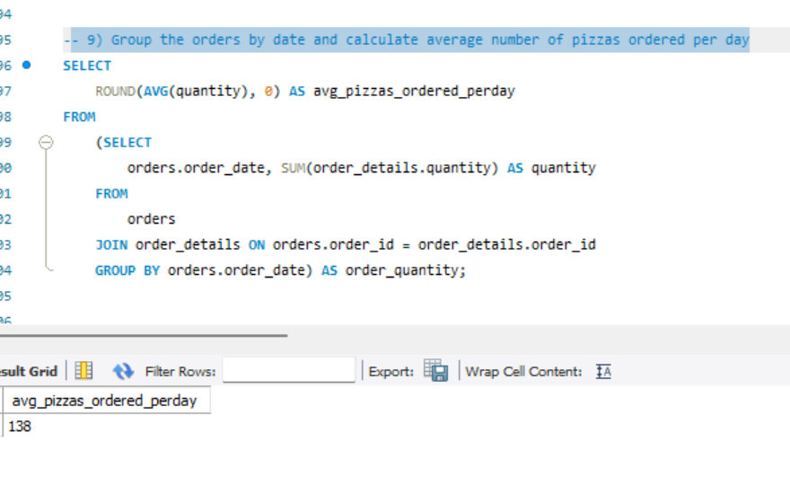

1. **Top 3 most ordered pizzas based on revenue**

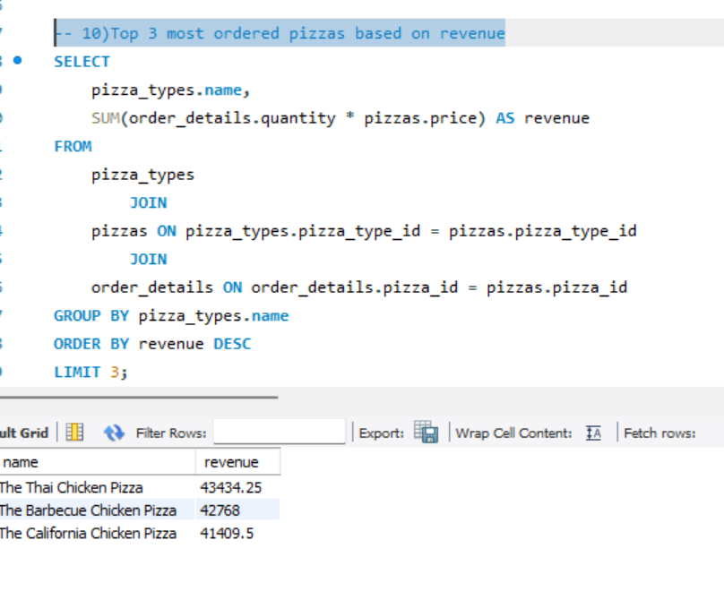

1. **Percentage contribution of each pizza type to total revenue**

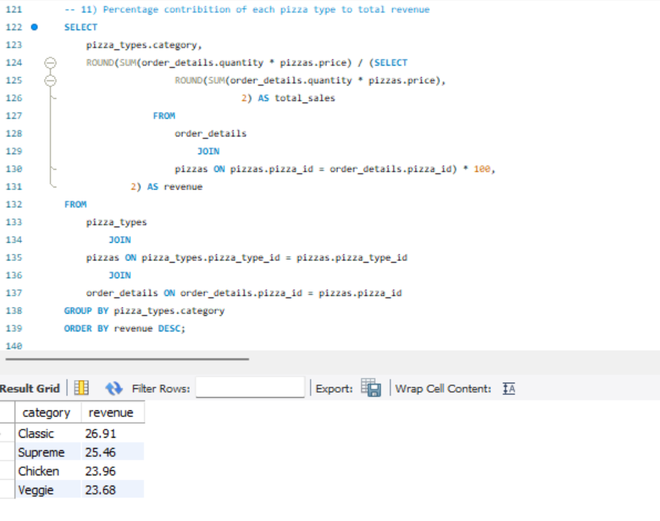

1. **Analysis on cumulative revenue generated over time**

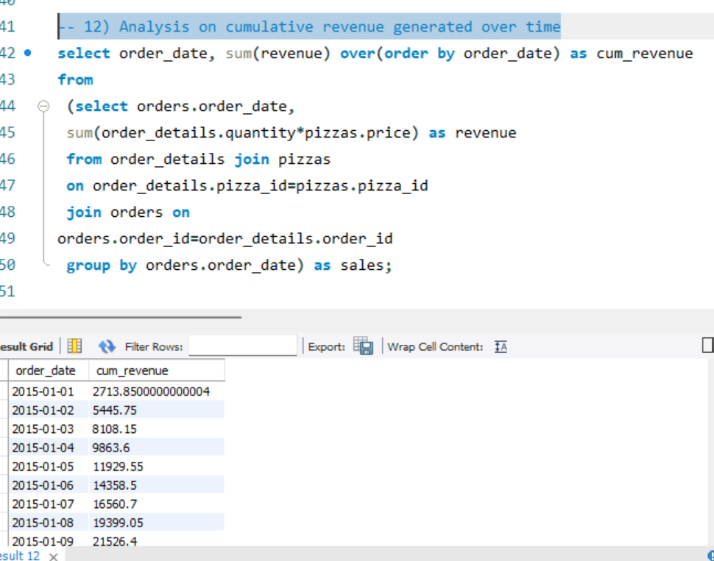

1. **Top 3 most ordered pizza types based on revenue for each pizza category**

